Franklin Colton Parry

CS 2600

Lab 3 Opnet

10/23/2013

1. The simple network had much faster page response times. It averaged just over .010 seconds over the course of the simulation. When the Background Utilization was introduced to the page response time average more than doubled to over .025 seconds. Obviously, the back ground traffic had an effect of slower page response times.

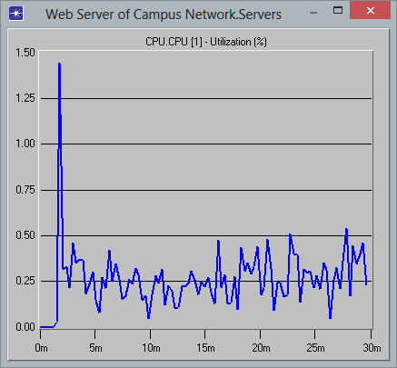 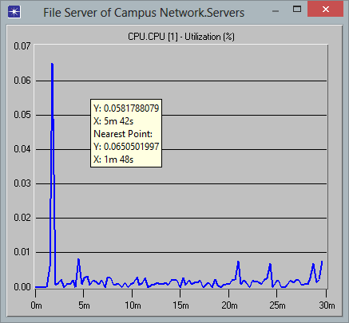

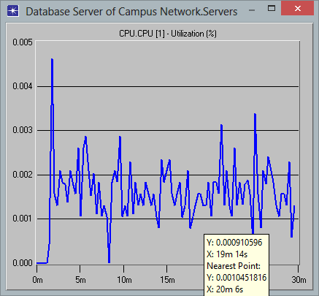

1. In the previous configuration of three separate servers, it appears the servers max utilization is just over 1.50 %. This is the same in the Unified server. The average utilization does increase in the unified scenario, but that is a good thing when we are talking about keeping our hardware busy working rather than idle. Typically the more use the better when talking about a piece of equipment.

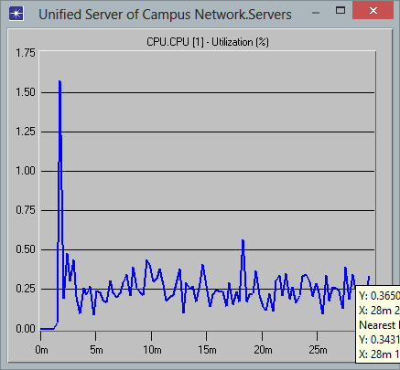

1. The increased bandwidth makes the response time much faster. It takes it from an average of over .025 to an average of just over .005. This would increase the performance of the network and move data much more quickly.

